Project Tweets
********************************************
Johanna Riquelme
Student 2023094

CCT College
Dublin, Ireland
2023094@student.cct.ie

CCT College Dublin

Assessment Cover Page
To be provided separately as a word doc for students to include with every submission

Module Title: | Advanced Data Analytics  Big Data Storage and Processing
Assessment Title: | MSC_DA_BD_ADAv5
Lecturer Name: | David McQuaid  Muhammad Iqbal
Student Full Name: | Johanna Riquelme A.
Student Number: | 2023094
GitHub repository | https://github.com/Johanna23cct/Integrated-CA2-MSc-2023094.git
Assessment Due Date: | 13/10/2023
Date of Submission: | 10/11/2023

Declaration

By submitting this assessment, I confirm that I have read the CCT policy on Academic Misconduct and understand the implications of submitting work that is not my own or does not appropriately reference material taken from a third party or other source. I declare it to be my own work and that all material from third parties has been appropriately referenced. I further confirm that this work has not previously been submitted for assessment by me or someone else in CCT College Dublin or any other higher education institution.

Tabla de contenido
I. KEYWORDS— 3
II. PROLOGUE: What is big data. 3
III. INTRODUCTION 4
IV. Big data storage and Processing 4
V. V. THE BIG WORK 6
VI. THE BIG WORK 6
VII. ACRONYMS 8
VIII. REFERENCES 8



KEYWORDS—
Big Data, Hadoop, MapReduce, spark, database, dataset, programming tools (R,Python, SQL, Scala, and Julia) , key tooling categories, Big Data (Hadoop, HTFS, Spark, MapReduce, abd DataBricks) Visualization (Tableau, Palantir, SAS, Pentalto and Teradata) Exabyte (EB=1024 PB) parallel and linear processing, graphs-Charts-Maps, Open source, Types of big data (structured, unstructured Semi-Structured, fault tolerance, action-transformation- prediction, implementation-Evaluation, Architecture, Gartner Glossary

PROLOGUE: What is big data.
First start my project, I must to research more and put my ideas in order, because when I started I had some terminology confusion and concepts not understood. To understand quickly I looking for in all Moodle and internet tutorial to create a visualization to help me understand, What is Big Data.
I would like to bring part of the history looking in the past time when all company working in smaller server with reduced memory and in the IT field, work was conducted using terminals that lacquered memory at the user stations, and all co-worker said to each other, Let me go with the dataset, because only one could work at a time. Well that was the best form to explain what is a small Data, with its characteristics, smaller, slowly, mostly located in storage systems within Enterprises or data centres and fragile to partial or total data loss due to disk errors or fire ware failures or absence of these.
I love Big Data is the best platform to interconnect everything and ever were with the management in huge volumes and could be structured, semi structured, or unstructured dataset. With speed and precision from multiple sources, recognition different formatting of data including image, record and more, and the more fantastic like angelical, the cloud. By the way, it is a meme so fanny about what happen when something is wrong in the cloud.


[1]. Like a Big data definition we can find in Gartner Glossary : Big Data is High-Volume, High-Velocity and/or High-Variety information assets that demand cost-effective, innovative forms of information processing that enable enhanced insight, decision making, and pros automation. __Gartner
Is good put on the table all the information and here you are all abpouth Bit, Bytes and more:
Bits | = | 0 or 1
8 Bits | = | 1Byte
1024 Bytes | = | 1 Kilobyte (KB)
1024 KB | = | 1 Megabyte (MG)
1024 MB | = | 1 Gigabyte (GB)
1024 GB | = | 1 Terabyte (TB)
1024 TB | = | 1 Petabyte (PB)
1024 PB | = | 1 Exabyte (EB)
1024 EB | = | 1 Zettabyte (ZB)
1024 ZB | = | 1 Yottabyte (YB)

Well if we go to talk about Big Data, we need to mention the four V’s of Big Data: Velocity: is the speed, Volume is huge big data, Variety is the diversity quality of data and Veracity is the certainty of data, the precision.
Is important considerate in the real live the impact of big data companies like Amazon, Netflix Spotify and the people how use virtual personal assistants like alexia or Siri on Apple devices, everyone’s use Big Data to devise answers to the infinite number of questions inclusive to help with some simple task like turn on or tur off the light. That is frequently in IoT – Internet of think , an internet- enabled connected network off smart devices such as sensors, processors, embedded devices and communication hardware for example, a security camera could continually upload footage, and a cloud-based big data algorithm may alert the user if any activity is detected.

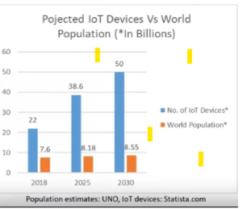
Next I would like to address the topic of Parallel processing and scalability, in linear processing le ogig go step by step following the instruction and when there are an Error must to back the begging but in parallel processing the instructions are then distributed to multiple execution nodes of equal processing power and are executed in parallel. If there are an error it can be fixed independent of other instructions in fact this stile of work reduced the processing time and loss data information and can processing big quantity of data.
Is necessary talk about what is data scaling in big data This simple mean adding additional nodes with the same capacity , the individual note arranged in this way are called a computer cluster, like this the multiple computation must coordinate with one another. This decreases the fault problem because the information is distributed across different nodes thus achieving a Fault tolerance enable a system to continue operating properly in the event of the failure of some of its components.
I want to mention what I learned a lot with this resource, like for example the six categories of Big Data tooling ,
Big Data Ecosystem
Data Technologies: Key technologies include Hadoop, HDFS, Spark, MapReduce, Cloudera, and Data bricks
Analytics & Visualization: Popular analytics tools available are Tableau, Palantir, SAS, Pentaho, and Teradata
Business Intelligence: Examples include Cognos, Oracle, PowerBI, Business Object, and Hyperion.
cloud server provider: Shared resources including computing, storage, networking, and analytical software.
NoSQL Databases: Examples include MongoDB, Couch DB, Cassandra, Redis.
Programming tools: R, Python, SQL, Scala, and Julia are common programing tools.
In this last point we ne to mention the Open source software, are free source code is open, open source license in Open source platforms, we have: The Apache Software Foundation, Linux Foundation, and Cloud Native Computing Foundation.
The biggest component of Big Data Open source is Hadoop and it plays a major role in this area, Hadoop MapReduce, Hadoop File System (HDFS) yet Another Resurge Negotiator (YARN) Open source has big data tools like Apache Hive and Apache Spark.
Where does Big data come from?
Social Data, Machine data, Transactional data.
What types of Data Base there are?
Structured, Unstructured, and Semi-structured.

INTRODUCTION
To introduce to my project first I made a thousand question external to why I am here and internal about this project. Well I will jump the first question and I will focus in the important, I am learning in gib steps and the speeds form than I have never had before.
Honestly, sometime I file so alone each time que my Lecturers said Any question, I go to outer space and see as question like star they are in the universe but for one hand I haven the clear idea to make a question and for the other hand I feel embarrassed to ask a question not at the level of my classmates. Then I felt like I can’t bother the professors and when I ask for technical support they ask me to make an appointment and so I feel without adequate support to facilitate my learning. All I have to this point is thank God, sure the ninety percent of a research with tears and a lot of effort that I only hope will result in a clearer understanding of where I am and consequently the path towards continuous improvement, which though the personal experimentation, I know, the technologies do not stop. And I want to be at the centre of the big data ecosystem to teach others who like e today feel on the threshold of something big without enough tools to cross the threshold.
By the way, I received one email with the great initiative to create a Student Mentor Team. Well that is what I mean. Well, I congratulate that initiative and I would have liked to have had it when I joined CCT College last semester.
Back to the topic, the real question in this point, what is the best wait to develop this project. And the best answer is follow the instructions that the professors have provided in CA2 for the tasks and report. So well, here I go.
Only I would like anticipate something, like my following big step to follow:
- Selecting the Database and storage
- Data preparation and Data Wrangling
- Comparative analysis of Databases
- Sentiment Analysis and Time-Series Forecasting
- Results and Visualization
- Dashboard creation
- Conclusion and future work
- Reference and citations
- Proofreading
As we can see, it is hard work. There is no time to waste.
Let’s go!

Big data storage and Processing

1. Like we will see in Figure 1 on the next page, the data provided for this project has five columns and for this assignment, the most important is the Columns number two. And from my point of view it is dirty, Due to my lack of experience; I did a clean-up and separated it into two new variable, one called Date and the other Time. From my point of view, experimentation enriches our knowledge. But the idea of selecting directly from that column the fields that interest me, which are the Month, Day and Year, is spinning in my head.
Fig 1. From Hadoop pyspark
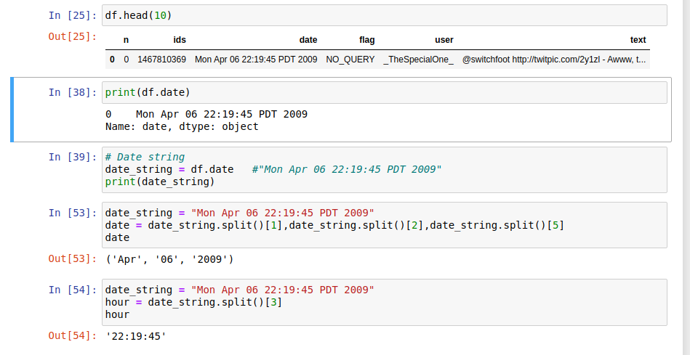
By the way, the name of our dataset is “ProjectTweets.csv” and is a large data set, like we can see,
Fig 2. Dataset’s Name and Size
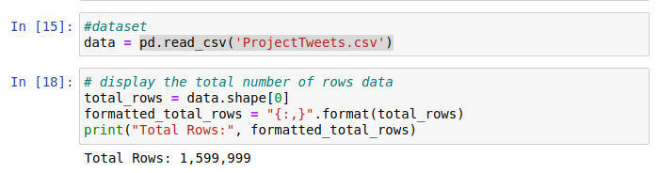
We can see in the follow fig, our dataset was put in Hadoop environment with the following command
Using Hadoop start scripts, well running ‘start-dfs’ and, ‘sh, start-yarn.sh’ Start the HDFS and yarn components of Hadoop, with are required for distributed storage and processing.
After starting Hadoop services, I can run JPS command to check the list of java process and verify that the Hadoop components are running.
Starting Pyspark after Hadoop service are running enables I can take advantage of a fully functional Hadoop cluster for distributed data processing this is the recommended approach for production use.
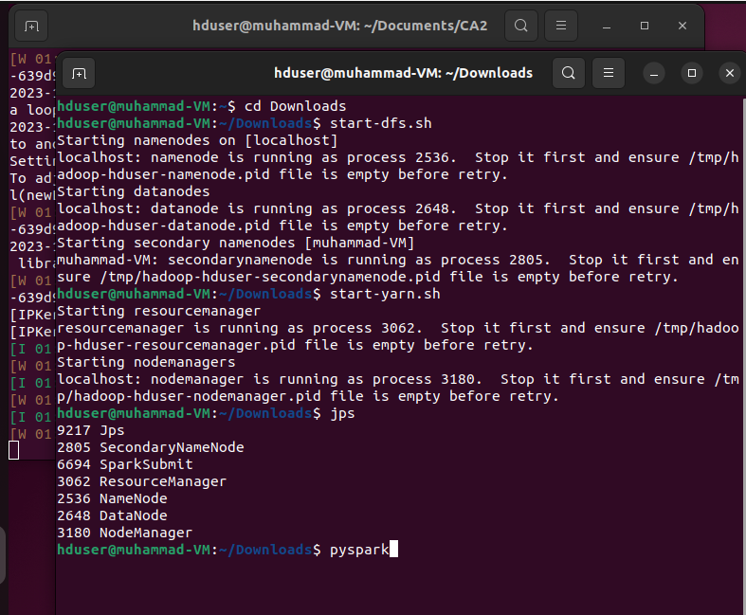
With the following command I copy the dataset from my server to Hadoop by the way only in this moment I could see the big data store process. And stay ready to use the 5V.
$ Hadoop fs -put ./ProjectTweets.csv /user1
$ Hadoop fs -ls /user1
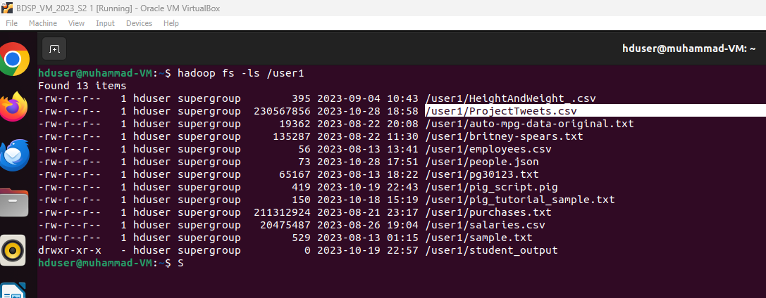
Finally I read the dataset from Hadoop environment, following you can see the two way to load the dataset, I will use direct from the path, to have one of five V' (Velocity)
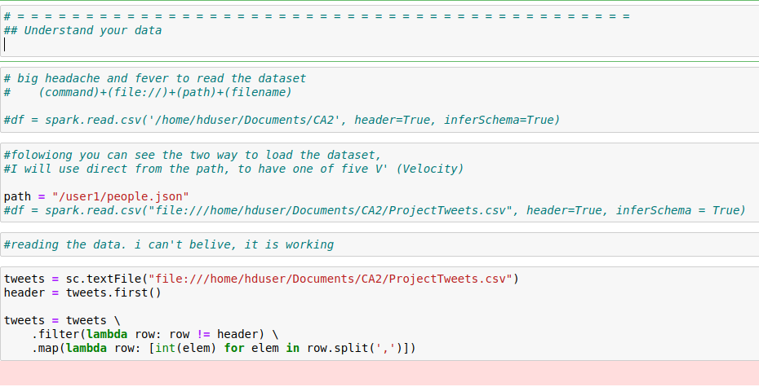
With those step we can see the dataset Utilization of Hadoop and spark to distributed data processing environment
Stored in Hadoop tool
P.S.: Something strange has happened, my Python files were corrupt and with the nerves I had I made a backup copy of my Word’s file without reviewing it, because I knew I had not modified it, so from Hadoop I sent it to GitHub, but strangely this file It was trampled by other information and when doing the backup my repository was trampled. I made no edits four days ago and was able to recover my Python codes and Word report. It's good that you learned how to use GitHub.
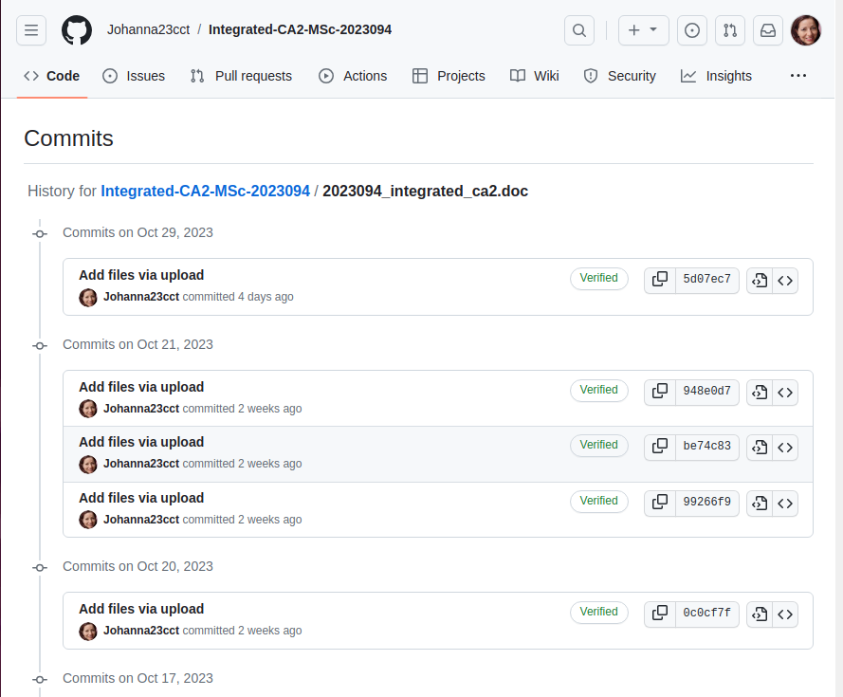
2. Well, after coming back from my state of shock and panic attack, I would like to following with the instruction, like a second toppy I hope to explain my justifications:
In relation to data processing and storage:
Rationale: Whereas data processing and storage options depend on the volume, variety, and velocity the best option for me is Hadoop. It was so difficult to learn but with all my effort it is an interesting platform to proccess and storage my data, about the choice of programming language I am not expert but Python it so frienship and I found a lot information in my Moodle to improve my knowledge, by the way. Data wrangling was so difficult because like you can see in my code, I made a lot mistake tray to clean a call some libraries which gave me a degree of complication.
At the moment I cannot talk about machine learning models because the algorithms do not work for me either. But I am doing my best to make this work; I hope to have a result as soon as possible. [0-40]
3. Comparative analysis for at least two databases using any benchmarking tool. By the way, I am expectant to learn more and can be able to compare this database with other Database because I think that is more near to the pass and the future and only wait to have enough time to made a comparative analysis with this two mentioned databases using YCSB.[0-10] According to what I learned in the class, this task seems very interesting to carry out, however time and the obstacles that delayed my project prevented me from reaching this stage.

THE BIG WORK

My job, more than creating codes and doing the assignment, was to read and review the videos of the classes, so I will proceed to document what I learned more than what I was able to do in Pyspark.

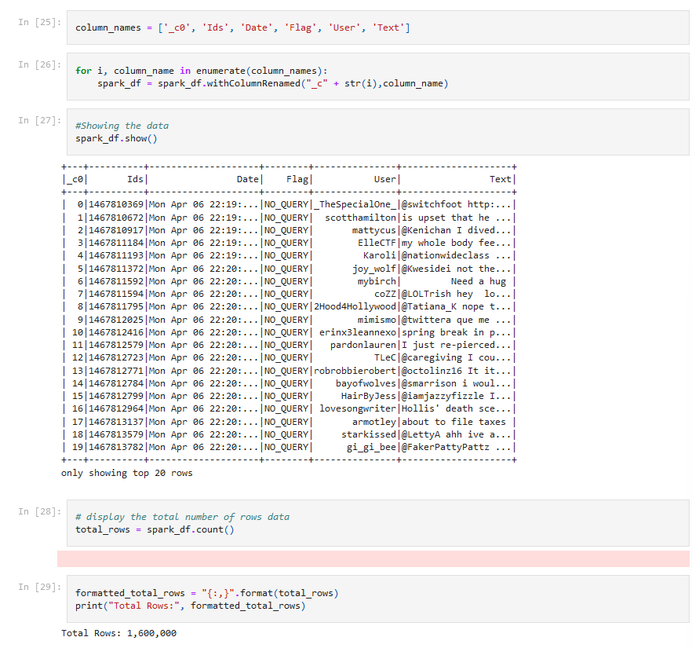

I will start with what is related to data analysis, definitions and what I found about its history and well I contribute my experience, although Data analysis is booming with technologies that allow us to analyse large volumes and various types of data, for me it has always existed We all know that being informed helps us make good decisions. From now on I want to explain my research in relation to the most important applications that this field has in daily life, the different levels of analysis of feelings that can be carried out on written texts, the tasks necessary to carry out their realization and a definition of the Opinion concept. Closing with the explanation of the most common difficulties faced in data analysis.

SA,: Analysis of feelings. for its acronym, is a field of research within NLP: Natural Language Processing, which consists of automatically extracting information extracted from the data in the texts of an analysed document using logarithms, achieving with this analysis visualize what type of behaviour has said document. As we could see in this project, social media data has great potential, because by analysing consumer comments we can see trends and each word can lead us to understand what is happening and if this is having a Positive Negative or Neutral. impact and the sooner we have that information, the sooner we can take steps to react to events.

WEB 2.0 and the origins of sentiment analysis, also known as opinion mining, which refers to the process of identifying, extracting and quantifying the emotions, opinions or attitudes expressed in a text, generally on social networks as I mentioned, so we saw in this project. plus reviews, comments or other free text data, that since bilateral connections were made and we are no longer left alone with an administrator who imposes his texts on us through some type of media, the opening to blog, Tweets and any digital media that we It allows us to interact and give voice and vote, it will open the door to analysis and begin to give the data a powerful tool and expressing our opinion allows us to have the feeling back instantly and in a real way time and thus without realizing it from this point we can consider the beginning of listening to the data speak

2000s: During this decade, significant advances were made in the field of natural language processing (NLP), leading to increased interest in automated understanding of human language. Initial techniques focused on rule- and lexicon-based approaches to identifying word polarities.
Advances in Machine Learning: Towards the mid-2000s and early 2010s, with the rise of machine learning, more sophisticated approaches based on learning algorithms emerged, such as the use of classifiers, neural networks, and sequential processing techniques to analyse the context and semantics of sentences.
Applications in business: As we have seen in classes, over time, companies began to use sentiment analysis to understand customers' perception of their products and services. This led to increased demand for sentiment analysis tools and platforms.

One of the most recognized and used definitions of sentiment analysis is:

"Sentiment analysis is the process of identifying, extracting, and quantifying the emotions and opinions expressed in a text to determine attitudes and feelings toward a particular topic."

This definition summarizes the essence of sentiment analysis, highlighting its goal of understanding the emotions and attitudes expressed in the text. There is no single person who has defined this area, as it has evolved over time with contributions from various experts in text mining, machine learning, and computational linguistics

However, many scholars, researchers, and practitioners in the field of natural language processing and artificial intelligence have contributed to the conceptualization and development of sentiment analysis, including Bing Liu, Bo Pang, Lillian Lee, and others who have worked on techniques. , algorithms and applications related to understanding feelings in text.

Going through the process that you can see in the following image was not easy at all.[0-10] clean the data, create new variables, analyse the dataset and make a small graph. That was all I could do

The Tokenization, never worked and for the same I coming with hardware problems, for divine grace, I received support to bought a new machine, and for my was all successful export and import the IOS and connect both computers to transfer the big data

5. Your forecast of the sentiment at 1 week, 1 month and 3 months going forward[0-10] Only I made the sentiment for all data, I could split for date and I not sure I can do that.

6. Presentation of results by making appropriate use of figures along with caption, tables, etc. and your dashboard for your forecast.[0-10]
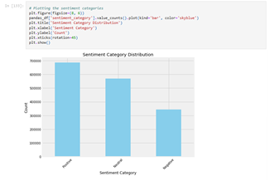

I would like to take advantage of this report to document the challenges encountered during the process.
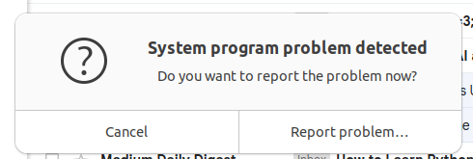

And in addition to the continuous machine errors was the migration of data from a Hadoop environment hosted in a Virtual Box to a new laptop.

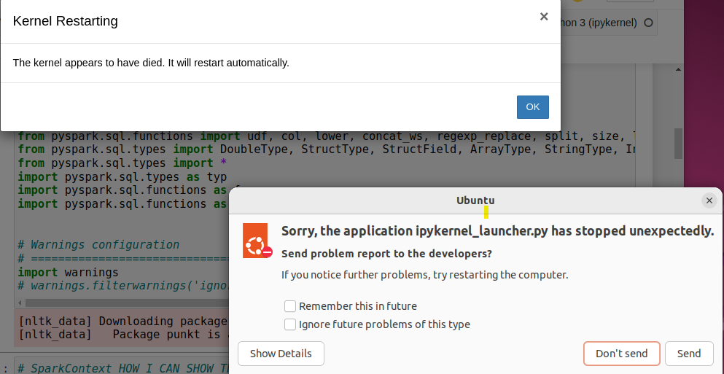

This migration is essential to continue data analysis and processing tasks in a more updated and efficient environment. The report describes the problems encountered, the strategies employed to overcome them and provides ideas for future reference.
The continuous Kernel errors and the blocking of the screen operation required a change of equipment and therefore a migration of data from the Hadoop Virtual Box to the new laptop. The importance of this migration has been the time gained, since to date we have more than 10 Tutorials that one by one I would surely continue installing and configuring my profile.

Challenges encountered

Export data from Hadoop Virtual Box
The biggest difficulty was putting the two machines online and, in addition to seeing them, being able to access the files, so it was necessary to remember all my technical support knowledge to be able to perform this task.

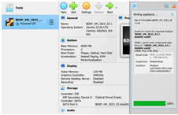

I would love for there to be a score for overcoming challenges and maintaining the plan in pursuit of the objectives, but I know there isn't one, I only have the value of what I learned and the satisfaction of having overcome the challenge.

ACRONYMS

SA: Sentiment Analysis
NLP: Natural Language Processing
HDFS: Hadoop Distributed file System
YARN: Yet another resource negotiator
BI: Business Intelligence
IoT: Internet of Think
UGC: User Generated Content
LAMP: Linux Apache MySQL PHP
RDD: Resilient Distributed Datasets.
DAG: Directed Acyclic Graph
MLlib: Machine Learning Library
UDFS User Defined Functions
JSON: Java Scrip Object Notation
APIS: Application Programming Interface
VADER: Valence Aware Dictionary and Sentimental Reasoner
JPS: Java Process Status
JVM: Java Virtual Machine
LDA: Laten Dirichle Allocation

Authors and Affiliations
"Spark: The Definitive Guide" by Bill Chambers and Matei Zaharia .
"Learning Spark" by Holden Karau, et al
. Python for Data Analysis by Wes McKinney
Data Analysis with Python and PySparks: Jonathan Rioux.

REFERENCES

[1].( Gartner Glossary)
- https://hadoop.apache.org/docs/stable/hadoop-mapreduce-client/hadoop-mapreduce-client-core/MapReduceTutorial.html
- https://ia600201.us.archive.org/7/items/HadoopInPractice/Hadoop%20in%20Practice.pdf
- https://www.manning.com/books/data-analysis-with-python-and-pyspark
- https://www.datacamp.com/tutorial/text-analytics-beginners-nltk
- file:///home/hduser/Downloads/cloud.jpeg

